Dynamic UI Cards
Introduction
In this document, we explain how to create a dynamic UI card connected to a CAP project with a deployed database running on SAP BTP.
We also clarify what makes a UI card dynamic and how it fits into a reusable design pattern.
What Are Dynamic UI Cards?
A dynamic UI card is a UI component whose content is determined at runtime, based on backend data, user context, or application state.
Unlike static cards, dynamic cards do not contain hardcoded values.
Characteristics of a Dynamic UI Card
A UI card can be considered dynamic when it meets the following criteria:
- Data-driven
The card retrieves data at runtime from a backend service.
- Bound to an OData service
Typically consumes an OData (or REST) endpoint exposed by a CAP service.
- Database-backed
Displays data stored in and retrieved from a database.
- Context-sensitive
The data shown can depend on:
  - the current user
  - user roles
  - filters or parameters
  - application context
- User- or role-based
Different users can see different data in the same type of card.
- Reusable design pattern
The card follows the same structure while allowing different datasets or configurations.

Creating a Data-Driven UI Card
Step 1: Database and CAP Setup
Before creating the UI card:
- Ensure that the database is correctly deployed.
- Deploy the CAP project to SAP BTP.
- Verify that the CAP service is accessible and exposes OData endpoints.
Once the CAP project is running on BTP, you can start creating your content package containing the UI card.

Step 2: Create the Content Package
After creating the content package, set up the UI card as usual.
A typical card setup contains:
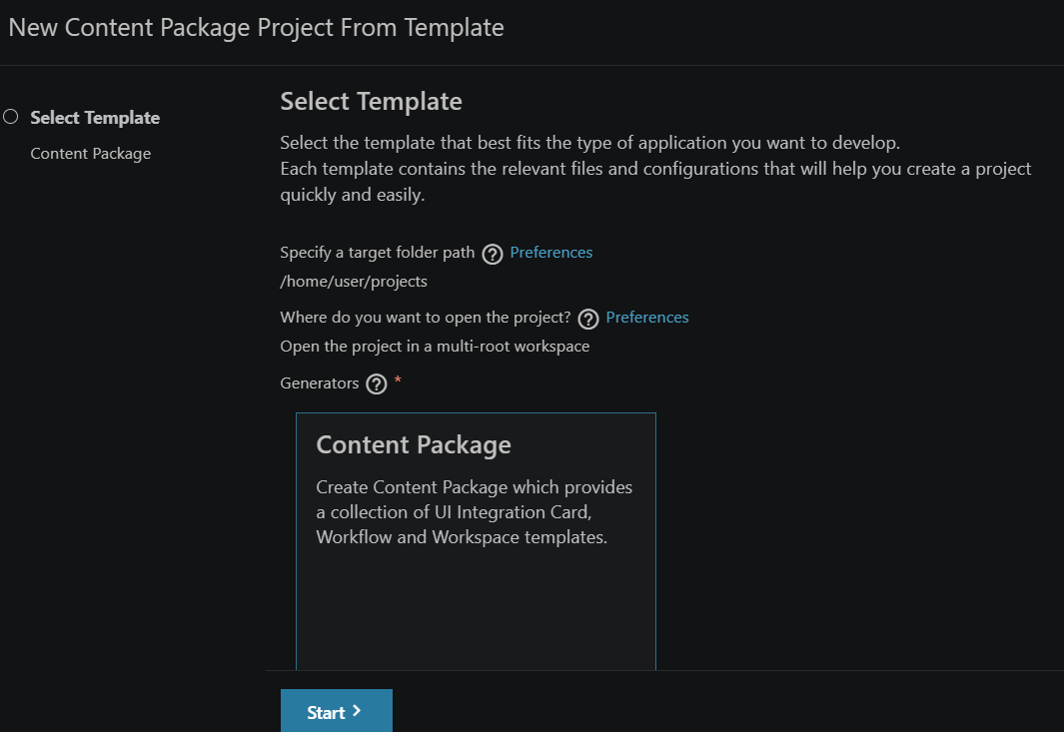
- cards/
  - manifest.json
  - content.json
  - roles.json
These files define:
- the card configuration
- the data source
- roles and access control

Declaring the Destination in the Card Manifest
The card manifest declares a named destination that will be resolved at runtime.
Inside manifest.json, you define a logical destination name that must exactly match a destination configured in BTP.
Example:

At this stage:
- {{destinations.bookshop}} is only a placeholder
- The actual URL is not yet known to the card

Choosing the Correct CAP Application URL
When deploying a CAP project, you typically get two applications:
- app_app
- app_app-srv
⚠️ Important:
You must use the -srv application URL (app_app-srv) because this application exposes the OData service.

Configuring the BTP Destination
Create a Destination
In SAP BTP:
- Go to Destinations
- Create a new destination from scratch
Required Destination Settings
- URL
Use the URL of the app_app-srv application
(the one ending in -srv.cfapps...)
- Authentication
OAuth2ClientCredentials
- Client ID & Client Secret
Found in:
CF Cockpit → Service Instances → <app>-auth → Service Key

- Token Service URL
Derived from the service key credentials:
<xsuaa-url>/oauth/token
The /oauth/token path must always be appended.

- Additional Property
HTML5.DynamicDestination = true
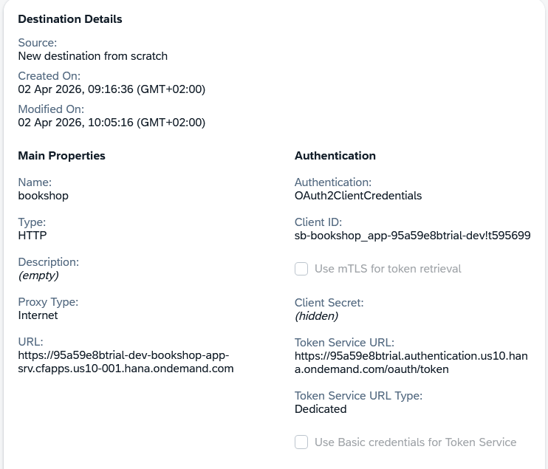
This is required for Work Zone to resolve dynamic destinations.

Runtime Resolution in SAP Work Zone
When the card loads in SAP Work Zone:
- Work Zone replaces
{{destinations.bookshop}}
with
/dynamic_dest/bookshop
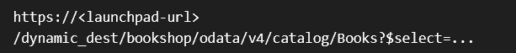
- The final request becomes:

Without HTML5.DynamicDestination = true, this request would return 404.

How Work Zone Proxies the Request
At runtime, SAP Work Zone performs the following steps:
- Receives the /dynamic_dest/bookshop/... request
- Looks up the bookshop destination in BTP
- Calls the token service URL using:
  - Client ID
  - Client Secret
- Retrieves an OAuth access token
- Attaches the token as:
Authorization: Bearer <token>

- Forwards the request to the target CAP service URL
Example forwarded request:
https://<app-srv-url>/odata/v4/catalog/Books?$select=ID,title,author,stock&$orderby=title

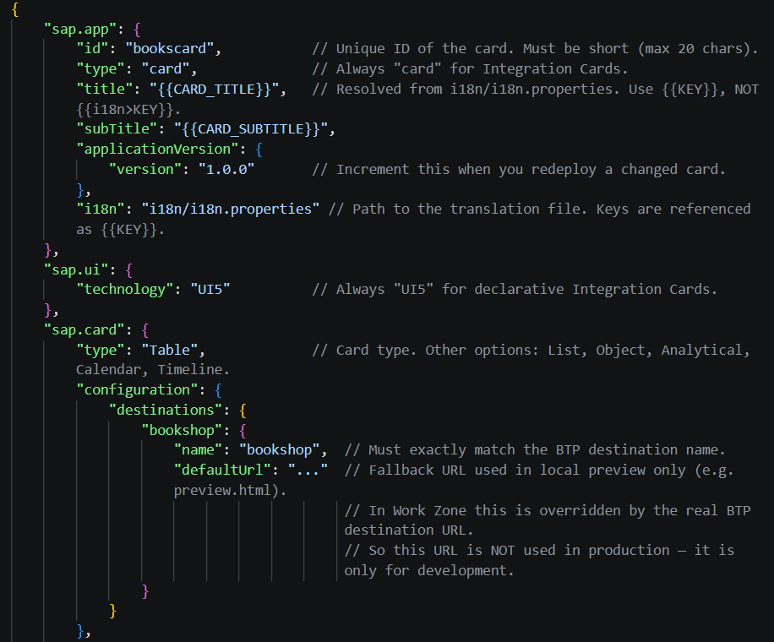

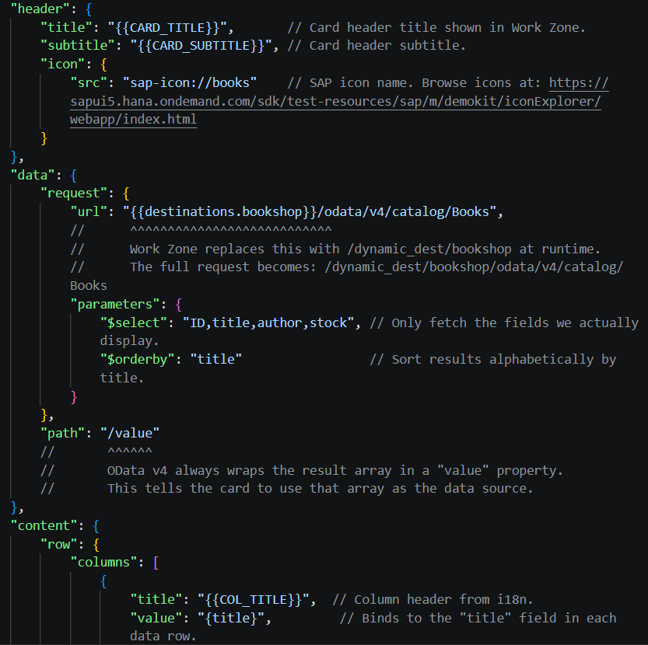

Visual summary:

Card manifest
{{destinations.bookshop}}/odata/v4/catalog/Books
│
▼
Work Zone (/dynamic_dest/bookshop/...)
→ looks up BTP destination "bookshop"
→ fetches OAuth token (Client ID + Secret → Token Service URL)
→ proxies request with Bearer token
│
▼
bookshop_app-srv (CAP OData)
→ validates token via XSUAA
→ returns { "value": [...] }
│
▼
Card table
path "/value" → rows
{title}, {author}, {stock} → columns

Where to Find Each Configuration Element
What you need | Where to find it
Destination name | Defined by you; must match the card manifest and BTP destination
Destination URL | cf apps → use the -srv application URL
Client ID / Secret | CF Cockpit → Service Instances → <app>-auth → Service Key
Token Service URL | <xsuaa-url>/oauth/token
OData path | Browse to <srv-url>/odata/v4/
Data path (/value) | Standard OData v4 result wrapper

Conclusion
By connecting a UI card to a CAP service deployed on SAP BTP and resolving the backend via a dynamic destination, the card becomes data-driven, context-aware, and dynamic.
By following a consistent card structure, the same design pattern can be reused across multiple cards and projects.

There is another way to make UI cards dynamic:
And that is through configuration editor. Note; only for work zone advanced!!

Here we will include a configuration file, so enable the changes we will make.
For example, we have a text field and we want to change the text this is possible when we add the card to the work zone page.

The only thing we need is;
    - /dt/Configuration.js
And that’s it

